Attendance Pattern Problem

Problem :

Teachers take attendance in class. Now such attendance data is published online. So At the end of the semester we want to give internal marks based on attendance pattern, analysis is to be done to find regular and irregular students and regularly irregular students.

Eg. the best record is

P P P P P P P P P P P P P P P P P P P P P

And the worst records is

A A A A A A A A A A A A A A A A A A A A A A

But such cases don’t occur practically

A student may take ill or focus on other project activity, so there can be patches of regularity example

P P P P P P P P A A A A P P P P P P P P

So this student can also be called regular.

If a students’ attendance record is

A A P P P P P P P P P P P P P P P A A A A,

the student is regular.

But if students’ records is

A A P P  A A A P P A A P A P A A P P P A A,

This student is irregular.

If the record look like

A A P A A P A A P A A P A A P A A P A A P,

The student is regularly irregular.

Please make an algorithm that can help teachers find such students automatically.

Test your solutions on array of inputs using C/C++/Java programs. Solution should be implemented in lab and output should be printed.

Solution : In this solution, I’m using file as a input instead of array.

Algorithm to identify different Patterns :

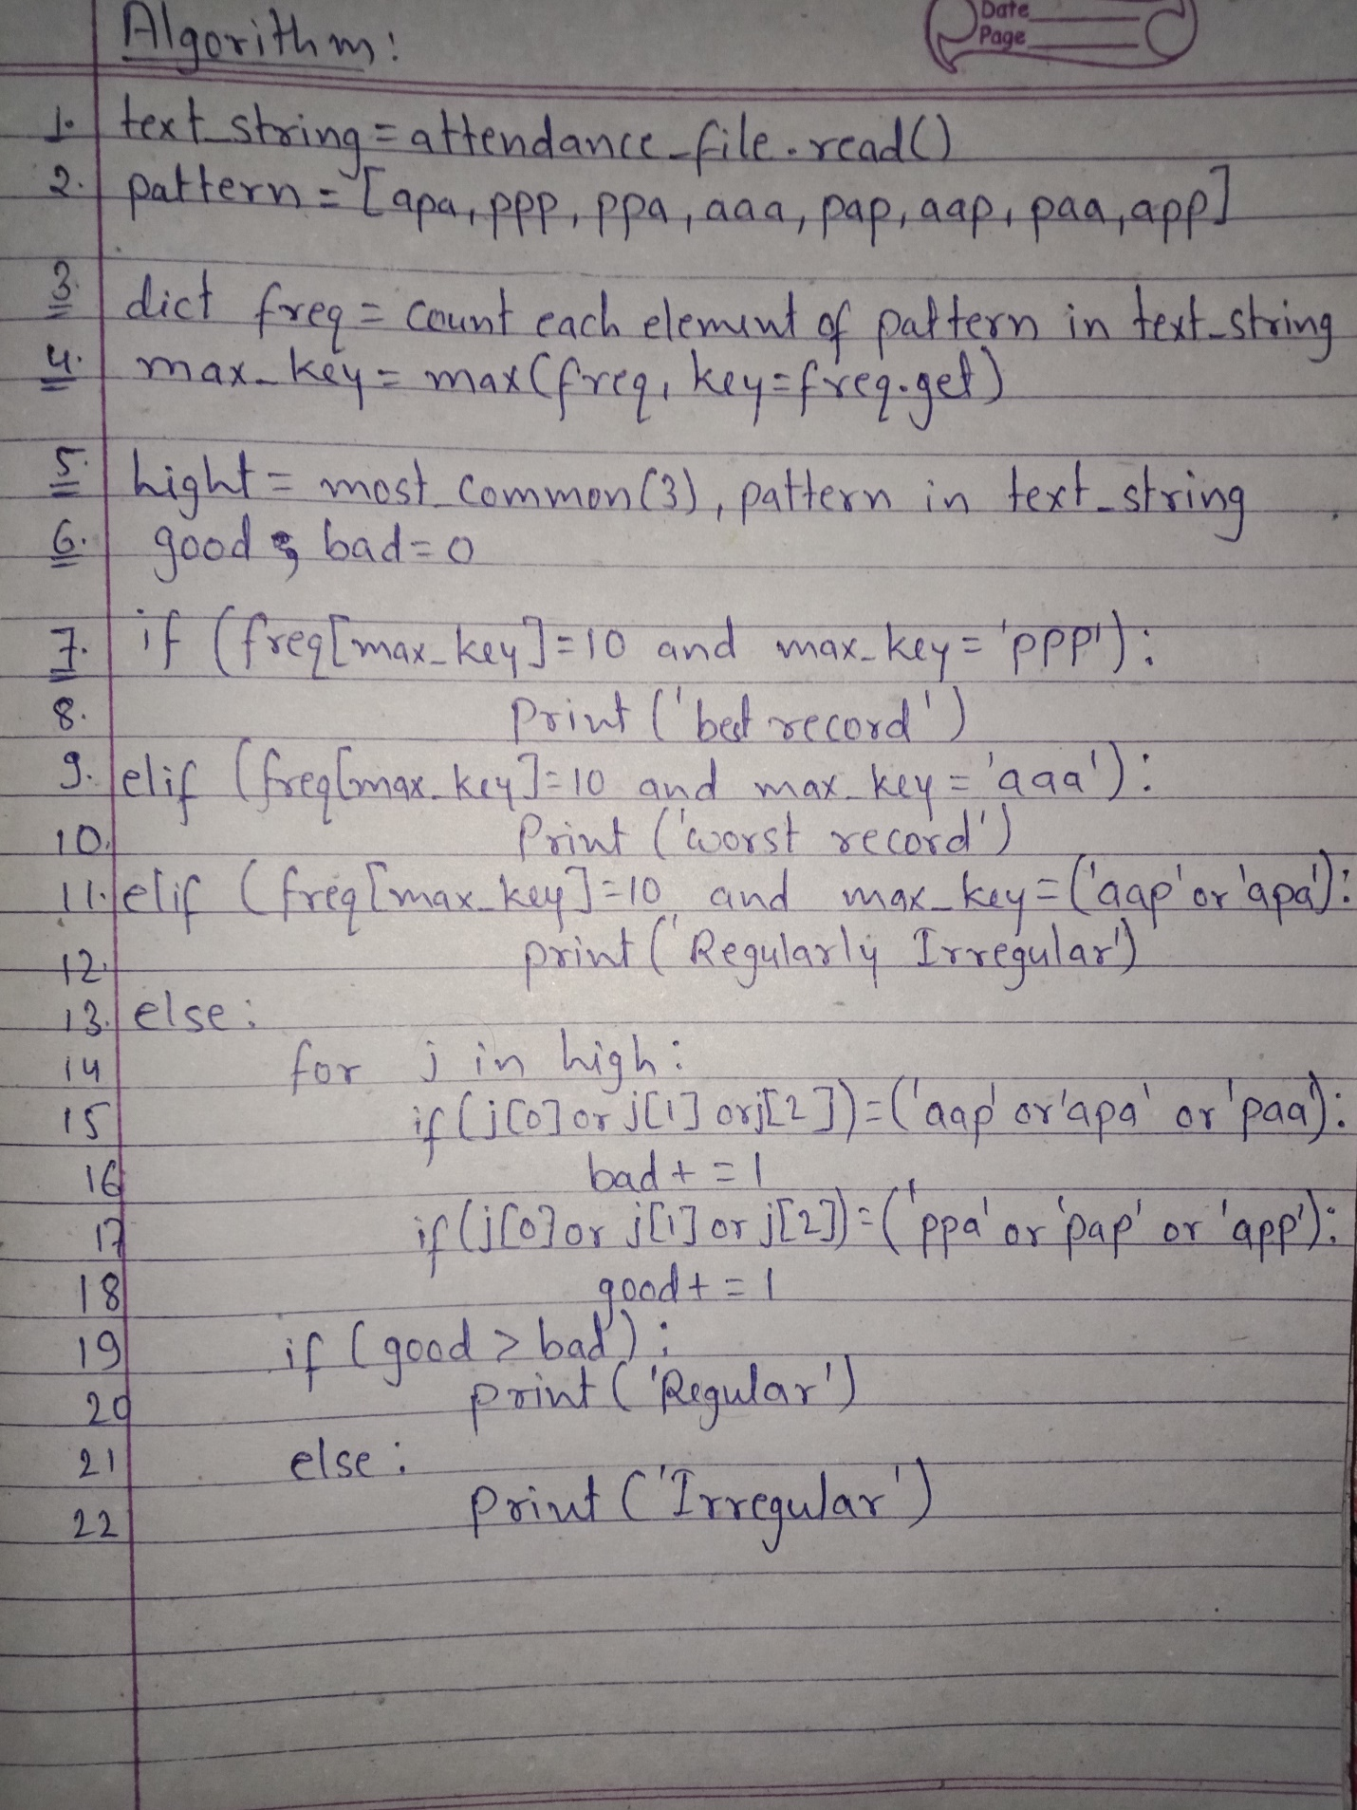

Files with different attendance pattern.

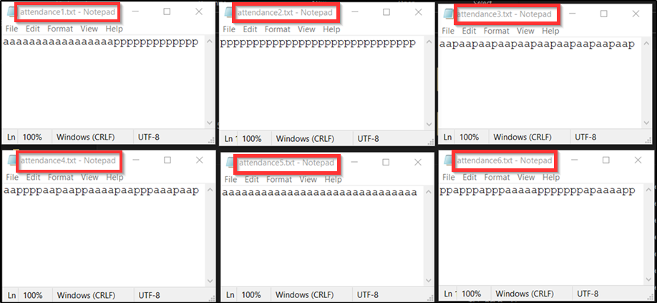

Program written in ‘Python’ to print regularity status of student from attendance patterns :

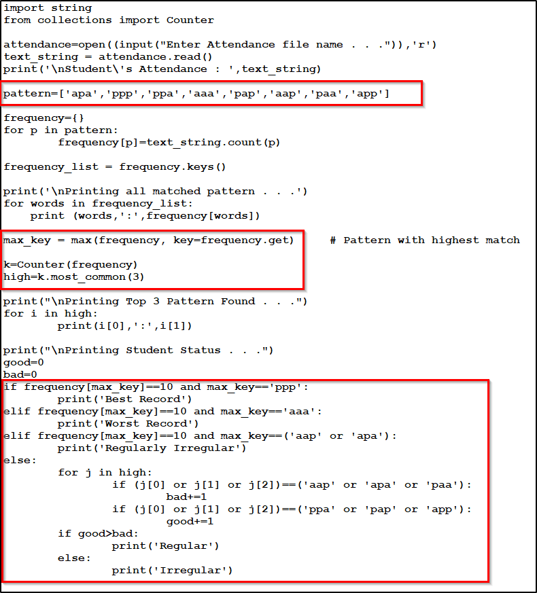

Outputs :

